Pokhara University

Level: Bachelor | Semester – Fall | Year : 2008
Programme: BE |  | Full Marks : 100
Course: Electronic Circuits I |  | Time : 3hrs.

Candidates are required to give their answers in their own words as far as practicable.
The figures in the margin indicate full marks.

Attempt all the questions.

1. | - Compare three amplifier configurations in terms of their input resistance, output resistance, current gain, voltage gain and phase reversal. Which of these configuration is used in intermediate stage of a cascaded amplifier and why?  - For the amplifier shown in figure, determine (i) voltage gain, (ii) the overall voltage gain, (iii) output voltage. Where: 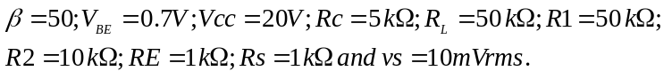  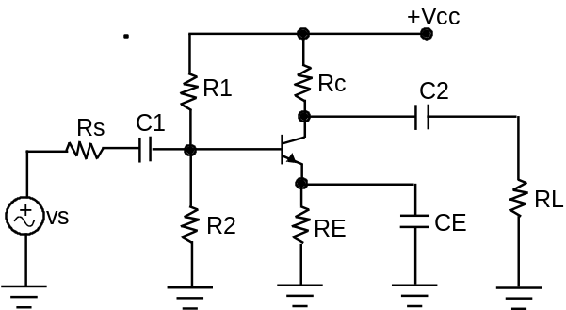 | 7  8
2. | - Define distortion and describe different types of distortion that occurs in amplifier.  - What is the principle of push - pull amplifier? Describe complementary - symmetry push - pull class B amplifier.  - What do you mean by Miller - Effect capacitance? Explain its effect in high frequency response of an inverting amplifier with necessary derivations. | 5  5  5
3. | - Draw the equivalent circuit of the voltage shunt feedback amplifier and derive the expression for input resistance.  - An amplifier has an open loop gain of 500 and a feedback ratio of 0.04. If the open loop gain changes by 25%, find the percentage change in closed loop gain.  - What do you mean by Power amplifier? Show that maximum possible efficiency of the series fed, class A amplifier is only 25%. | 5  5  5
4. | - State Barkhausen criteria for oscillation. Explain the working mechanism of wein bridge oscillator.  - What is piezoelectric effect? Describe crystal oscillator. Draw necessary wave forms and derivatives. | 8  7
5. | - What are the main characteristics of an ideal operational amplifier? Draw an Integrator circuit and derive its output expression.  - Design an operational amplifier circuit using tow inverting configuration to produce output V₀ = -10V₁+5V₂+5V₃ -20V₄. | 8  7
6. | - Draw Binary Weighted Resistor DAC and explain its operation. Mention its drawbacks and explain how can you avoid it?  - Derive the expression of efficiency for full wave rectifier. What is ripple factor? | 8  7
7. | Write short notes on (Any Two)  - Emitter follower amplifier  - Flash ADC  - Switched Mode Voltage Regulators | 5×2

